MjH\; Nkdpiyg; gs;sp – nghd;Ndhp
SAT – Answer Key – 09.10.2020
ghlk; - jkpo; kjpg;ngz;fs; - 50
tFg;G – 10
gFjp – 1
tpilfs; rhpahf ,Ue;jhy; 1 kjpg;ngz;> gpiofs; ,Ue;jhy; ½ kjpg;ngz; toq;fTk;
m) rhpahd tpiliaj; NjHe;njLj;J vOJf. 10 X1 = 10
1. <) rpyg;gjpfhuk;
2. <) newpNahL epd;W fhty; fhg;gtH
3. ,) coT> VH> kz;> khL
4. ,) typikia epiyehl;ly;
5. m) jpUg;gjpAk; jpUj;jzpAk;
6. M) ,uz;lhk; ,uhruhr Nrhod;
7. ,) k.ngh.rp.
8. M) 1902
9. M) 3
10. m) rpd;dg;gps;is
gphpT – 2
2 gpiofSf;F ½ kjpg;ngz; Fiwf;fTk;.
midj;J FWtpdhf;fSf;Fk; tpilasp 5 X 2 = 10
11. nka;f;fPHj;jp ghlg;gLtjd; Nehf;fk; ahJ?
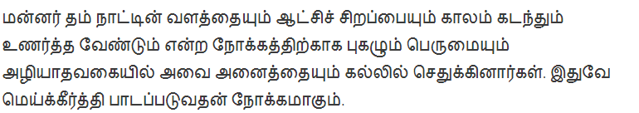
12. tWikapYk; gbg;gpd; kPJ ehl;lk; nfhz;ltH k.ngh.rp. vd;gjw;Fr; rhd;W jUf.
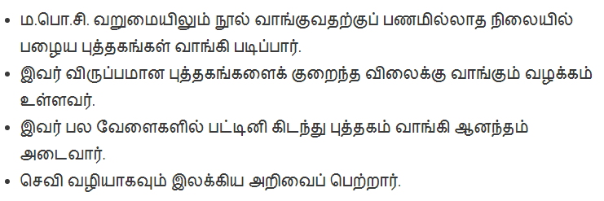
13. Gwj;jpizfspy; vjpnujpHj; jpizfis ml;ltizg;gLj;Jf.
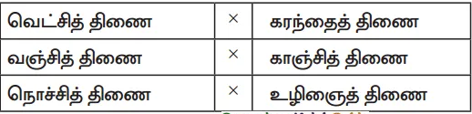
14. ghrtH> thrtH> gy;epz tpiyQH> ckzH – rpyg;gjpfhuk; fhl;Lk; ,t;tzpfHfs; ahtH?
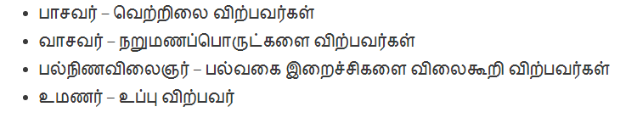
15. rpyg;gjpfhuk; vt;thW rpwg;gpf;fg;gLfpwJ?
Kj;jkpo;f; fhg;gpak;> Fbkf;fs; fhg;gpak;.
gphpT – 3
kdg;ghlg; ghliy mbkhwhky; vOJf. 1 X 3 = 3
16. J}Rk; -------- vdj; njhlq;Fk; rpyg;gjpfhug; ghliy vOJf.
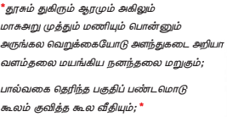

fbjk; vOJf. 1 X 7 = 7
17.fbjj;jpy; rhd;wpw;fhf xU ngaUk; tpyhrKk; nfhLf;fg;gl;Ls;sJ. eP cd; ngaiuAk; cd; tpyhrj;ijAk; vOjNtz;Lk;.

